MY PYTHON DOCUMENTATION

INTRODUCTION

PYTHON: **Python** is a very popular general-purpose interpreted, interactive, object-oriented, and high-level programming language.

->Python is an easy to learn,readable

🡪Python is dynamically-typed

🡪it has vast amount of libraries and modules( numpy ,pandas ,math ,time ,date)

🡪we can build our logic with built in type functions or with our own logic

Ex: program to convert a number decimal <-> binary

Using built in function:

# input a decimal num

decimal_number = int(input(“enter a decimal number:”))

#convert to binary using bin() function

binary_num = bin(decimal_number) #4 =100(binary)

Print(“binary format”,binary_num)

Explanation : bin() converts decimal to binary format

Without built in functions:

def deci_to_binary(num):

binary_num = “ “

if num == 0:

return “0”

while num > 0:

remainder = num % 2

binary_num = str(remainder) + binary_num

num = num // 2

return binary_num

# input a decimal num

num = int(input(“enter a decimal number:”))

binary_num = print(deci_to_binary(num)) # calling function

Print(“binary format”,binary_num)

Explanation: here we use our own logic by dividing the number with 2 and storing the remainder in “decimal number”

Variables and Data types:

In Python, you can store data in variables. Data types include:

1.Integers: Whole numbers, e.g., 23

2.Floats: Decimal numbers, e.g., 3.1235

3.Strings: Text, e.g., "Hello, ACCELYZIE"

4.Booleans: True or False values, e.g., True

5.List : list represents ordered , mutable sequence of values (e.g [1,2,3,4,”sis”])

6.Tuple : Tuple data type represents ordered,immutable sequences of values (e.g.,(1,2,3,8,6))

7.Dictionaries : Dictionary data type represents collection of key – value pairs(e.g {‘name” : “keerthi”, “age” :20})

8.None: None type represents the absence of value e.g: None

9.set :it is unordered collection of unique elements e.g {1,3,5,6} (no duplicate values)

Basic Operations:

You can perform arithmetic operations like addition, subtraction, multiplication, and division using symbols +, -, *, /.

Ex:  PERFORM ALL ARTHMETIC OPERATIONS ON 3 NUMBERS

a = int(input("enter 1 st number:"))

b = int(input("enter 2 nd number:"))

c = int(input("enter 3 rd number:"))

print("arthmatic operations:")

print("addition of  numbers:",str(a+b+c))

print("subtraction of 3 numbers:",str(a-b-c))

print("multiplication of 3 numbers:",str(a*b*c))

print("dividion of 3 numbers",str(a / b / c))

print("modulus of 3 numbers:",str(a % b % c))

Print Statements:

We can display information using the print() function. For example:

print("Accelyzei")

Input from Users;

We can get input from users using the input() function:

Num = int(input(“enter a number:”))

name = input("What's your name? ")

print("Hello,", name)

Conditional Statements:

These help you make decisions in your code using if, elif (else if), and else. For example:

 vote eligibility

'''age = int(input("enter your age:"))

if(age >= 18):

    print(" you are eligible to vote:",age)

else:

    print("you have ",18-age ,"years to get eligibilty") '''

# checking credintials:

print(" printing person details:")

name = input("enter your name:")

age = int(input("enter your age:"))

if (name == "keerthi chavla" or "Prasanna"):

    print("welcome ",name ,"your age is",age)

else:

    print("invalid credintials: please enter again")

if: if checks the condition and execute the statements if condition TRUE other wise not execute

else:if condition not True then else statement execute

Loops:

let you repeat actions. for loops are used to iterate over sequences

while loops run as long as a certain condition is true.

EX:

n = int(input("no of sets to ombine"))

for i in range(n):

    n_el = int(input('enter no of elements in set:'))

    s = set()

    for j in range(n_el):

        ele = int(input("enter your set element:"))

        s.add(ele)

    s=s.union(s)

above example for union of sets

for loop to iterate no of required sets to combine

Dictionary operations:

Creation of dictionary

d1 = {"company" :"Apple" , "model":"11 pro" , "year":2023}

# creating dictionary using from keys() 🡪creates with keys and values

a=["name","food","movie"]

b = 3

# create a dict with new keys and values

d2 = dict.fromkeys(a,b)

print(d2)

op: {“name”:3, ”food”:3 ,”movie” :3 }

nested dictionaries

ex:

details = {'person1': {"name":"aswini","age":20,

                        "address":{'dist':'sklm','vill':'dosari'}},

           'person2':{"name":

    "prassu","age": 19,

    "address":{'dist':'vizayanagaram','vill':'rajam'}

    }}

print(details)

print("persion 1 name:",details['person1']['name'])

print("person 2 address:",details['person2']['address']['vill'])

Functions:

->Functions are reusable blocks of code which perform particular task

-> helps to organize your code and make it more readable.

Ex: str = "ALPHA NUMARO"

def change_name(str):  #function definition

    print("our company name is:",str)

    return

# new name= "Accelezie"

change_name("Accelyzie")  #calling function

print("company old name is :Alpha numaro")

change_name(“Accelyzei”) # we send the value to function definition.

Op: our company name is: Accelyzei

Company old name is : Alpha numaro

Comments

We can add comments to explain your code.& for future reference, Comments are not executed and start with #:

# This is a comment explaining the following line

age = 25 #intialize age as 25

“ “ “

These are multi line comments

Hello

Hi

“ “ “

Libraries and Modules:

->Python has a vast ecosystem of libraries and modules that provide additional functionality.

->We can import and use them in your code:

Time and Datetime :

import time

import calendar

import pandas as pd

# we have to import these modules

now = time.time()

print("time:" ,now)

localtime = time.localtime(time.time())

print(localtime)

time.localtime() 🡪 gives present time in readable format

Extract year,month from data frame

data = {'Date': ['2023-09-05', '2023-08-15', '2022-07-25', '2022-06-10']}

df = pd.DataFrame(data)

df["dob"] = pd.to_datetime(df['Date'],format = '%Y-%m-%d')

#extracting year month from date

df['year']  = df['dob'].dt.year

df['month'] = df['dob'].dt.month

df= dob year month

03-10-2023 2023 10

15-08-2023 2023 08

25-07-2022 2022 07

Astime():

print("normal time readable format:",time.asctime(time.localtime(time.time())))

print("calender functions")

cal = calendar.month(2002,5)

print(cal)

op:calendat.moth() give particular month of given year

Date: 13-09-2023

FILE HANDLING OPERATION:

file operations:

The open() function takes two parameters; filename, and mode.

import os

f1 = open("demo.txt","w")

f1.write("documentation should be clean and simple")

f1.close()  # close the file after your work

print("reading data")

f1 = open("demo.txt","r")

my_data = f1.read()   # store read data in variable

print("demo file data:",my_data)

f1.close()

#

print("appending data")

f1 = open("demo.txt","a")

f1.write("you learn new things every day")

f1.close()

print(" data appended & file closed")

#f1.append("you learn everyday")

# delete files

print("delete files fileobj.remove(file_name)")

os.remove("file2.txt")

# to avoid error first check whether the file exist or not

if os.path.exists("none.txt"):

    os.remove("none.txt")

else:

    print("such a file not exist in your system")

print("we can remove dir --> os.rmdir(folder)") # can remove empty folders only

append -> add data at the end of file content

write mode : over write the previous data

delete -> to delete file we use os.remove() method

mport os

# file operations

#strip() removes given char from both ends

f= open("file2.txt",'r')

line = f.readline()

print("before strip:",line)

line2=line.strip("A")

print("after strip:",line2)

line3=line.strip(" ")

print("after strip only spaces:",line3)

# right strip

line4 = line.rstrip("e")

print("removeing right char:",line4)

desc: to operate on file first we have to open particular file in required mode

"r" - Read - Default value. Opens a file for reading, error if the file does not exist

"a" - Append - Opens a file for appending, creates the file if it does not exist

"w" - Write - Opens a file for writing, creates the file if it does not exist

"x" - Create - Creates the specified file, returns an error if the file exists

‘ rb’ – open file for reading binary format

after our file operatons we should close our file

file_obj.close()

ex:

mport os

def create_file(filename):

    try:

        with open('filename','w') as f:

            f.write("hello accelyzie \n")

        print("file" + filename + "created with data successfully" )

    except IOError:

          # if we want to specify error

          print("error : file was not created" +filename)

def read_file(filename):

     try:

          with open(filename,'r') as f:

               content = f.read()

               print(content)

     except IOError:

          print("successfully file content readed" +filename)

def append_data(filename,text):

     try:

          with open(filename,'a') as f:

               f.write(text)

          print("text appended to the file" +filename)

     except IOError:

          print("could not  appended to the file" +filename)

def rename_file(filename,newfile):

     try:

          os.rename(filename,new_file)

          print("file:" + filename + "renamed to"  +new_file)

     except IOError:

          print("could not rename the file" +filename)

def delete_file(new_file):

     try:

          os.remove(new_file)

          print("file" +filename + "deleed successfully")

     except IOError:

          print("error : can not delelted" +new_file)

filename = "ex.txt"

new_file = "changed_ex.txt"

text = "i am add some data"

create_file(filename)

read_file(filename)

append_data(filename,text)

read_file(filename)

rename_file(filename,new_file)

delete_file(new_file)

ex: file programs

1. Count no of words

Step 1: open the file in “r” mode

Step 2: read the file data in variable

Step 3: split the content at space using .split() method

Step 4:close the file

#no of words in the file

f2 = open("demo.txt","r")

f2_content = f2.read()

words = f2_content.split()

print("no of words:",len(words))

print("words",words)

f2.close()

2.merge files and copy the data into new file

print(" mergeing  files data")

file1 = open("demo.txt",'r')

file2 = open("prog.txt",'r')

new_file = open("p_lang.txt",'w')

a = file1.read()

b = file2.read()

c = a + "\n" + b  #merge files data

new_file.write(c)

file1.close()

file2.close()

new_file.close()

print("data successfully merged")

c = a + “\n” b # merge two files data into one variable

new_file.write(c) # write the data into another file using write()

after we should close all the files to avoid errors

PYTHON DATA STRUCTURES:

PYTHON STRINGS:

1.String : sequence of characters

Ex: s= “ Accelyzei – (accelerate , innovative , analyse) “

Sliceing -> we can get particular character or sub string using sliceing by index

S[1] -> c

S[1:7] -> ccelyz #( returns1 to 6 index chars)

Negative indexing:

S[-3] -> s # gives last to 3 rd character

S[-5 : -2] -> yze # 5,4,3 rd charcters from last

2. ->The format() method takes the passed arguments, formats them, and places them in the string where the placeholders {} are

-> we can insert values in string using format method

Ex:

String formatting: # str operations

s = "Accelyzei - ( Accelerate , Innovative, Analyze) "

print("given string:",s)

print("sliceing:", s[1:4])

print("negative indexing s[-5:-2]:",s[-5:-2])

# string formating

#we can insert numbers into stings using format()

s1 = "we got independence in {} and we celebrate  {} -15 as independence day "

year =1947

print(s1.format(year,"August"))

s2 = "today is better than {0} we never forget {1}"

print(s2.format("Yestarday","hope")

Ex2: print palindrome strings

Palindrome menas string should be same after reversing : sis <-> sis

li = ["mom","you","sis","mean","dad"]

pal_str = []

def is_pal(st):

    if st == st[ : :-1]:

        pal_str.append(st)

    return

for st in li:

    is_pal(st)

print("original strings:",li)

print("palindrom strings:",pal_str)

Op: original strings: ['mom', 'you', 'sis', 'mean', 'dad']

palindrom strings: ['mom', 'sis', 'dad']

ex:3 # count no of vowels consonets using string methods

# counting no of vowels consonents

vowels = {"a","e","i","o","u","A","E","I","O","U"}

nv = 0; nc = 0 ; n_upper = 0 ; n_lower = 0

alph =0

for i in range(len(s)):

    if s[i].isalpha():

        alph = alph + 1

        if s[i] in vowels:

            nv = nv + 1

        else:

            nc = nc + 1

        # count no of lower case ,upper case characters

        if s[i].islower():

            n_lower = n_lower + 1

        if s[i].isupper():

            n_upper = n_upper + 1

print("no of alphabets in string:",alph)

print(" no of vowels in string:",nv)

print(" no of consonents in string:",nc)

print(" no of n_lowercase charcters in string",n_lower)

print(" no of n_uppercase charcters in string",n_upper)

2.set : set is a unordered collection of elements

-> mutable

->not allow duplicate elements

S = set() or set ={ 3,4,5} #declaration of set

3.Frozen Set: it is one type of set

-> not changeable and does not allow duplicate values

-> used as dictionary keys and elements of set

1 = frozenset([0,1,2,3,4,5,"mom"])

f2 = frozenset([0,3,8,4,5,6,2,"sis"])

print(f1)

print(f2)

union = f1.union(f2)

intersection = f1.intersection(f2)

difference = f1.difference(f2)

print("union:",union)

print("intersection:",union)

print("difference:",union)

# used in dictionaries

dic_with_frozenset = {f1:"val 1",f2:"val 2"}

print("dic_with_frozenset:",dic_with_frozenset)

# set of frozen sets

print(" set of frozen sets:",{f1,f2})

4.Stack: it is one type of data structure which follows (Lifo)

-> last in first out

-push() # add elements into stack

Pop() # remove last element

Pee() # top most elemet(last inserted)

EX:

from collections import deque

print("stack using deque")

stack = deque()  # dynamic and efficient

stack.append("home page")

stack.append("gallary")

stack.append('contact page')

stack.append("catalogue page")

print(stack)

print(stack.pop())

print(stack)

deque() it provide stack structure dynamically

->easy to implement stack operations

Note: we can implement stack using list ,but linst costly to copy elements some stack operations

Ex 2:

Implementation of stack using class:

#stack using class

class stack1:

    def __init__(self):

        return self.container = deque()

    def push(self,val):

        return self.container.append(val)

    def pop(self):

        return self.container.pop()

    def peek(self):

        return self.container[-1]  # top most element

    def is_empty(self):

        return len(self.container) == 0

    def size(self):

        return len(self.container)

after that we create class object s= stack1()

and call the class methods:

s=stack1()  # stack1 object creation

s.push(5)

s.push(6)

s.push(9)

s.peek()

s.pop()

Application: moving to previous window in browser

Ex:

Op: deque(['home page', 'galary', 'contact page', 'catalogue page'])

Op: Pop() -> catalogue page # pop() means remove last element

DATE:14-09-2023

NUMPY:

Why numpy and advantages:

->numpy is a python library, used to working with arrays

->much faster and efficient than list

->stores homogenous objects

->used for scientic computations on large no of data

->multi dimentional and provides element wise operation

Import numpy library

Import numpy as np

A1 =np.array([4,8,9,7])

creation of numpy array

import numpy as np

a1 = np.array([4,2,23,3,16])

print("a1",a1)

print(type(a1))    # version of np

print("version of ",np.__version__)

print("nested arrays and multi dimentional arrays:")

a2 = np.array([43])

print(a2,type(a2))  # o -dimentional array

a3 = np.array([1,2,3,4,5])

a4 =np.array([[4,5,6,3],[8,9,7,19]])

mu_a5 = np.array([[[1,2,3],[4,5,6]],[[7,8,9],[10,11,12]]])

print(mu_a5)

print(type(mu_a5))

print("dimentionality of mu_a5",mu_a5.ndim)

print("dimentionality pf a4:",a4.ndim)

print("Accesing array elements")

print("1 st row 2nd col elenemnt:",a4[0,1])

print("2 nd row 4 th col element:",a4[1,3])

print(" -ve indexing:a[0,-1]",a4[0,-1])

print("2 nd table 1 st row 1 st col element:",mu_a5[1,0,0])

print("a3",a3[: :2])

a6 = np.array(["jaga","prassu","mom","siddu"])

arr2 = np.array([3.4,1.2,5.6,7.0])

print(a6)

print("a6 data type:",a6.dtype)

#print("convert data type using astype:",a6.astype(int))

print("convert data type using astype:",arr2.astype(int))

Array multi dimentional

To know the dimentionality ->arr.ndim

🡪We can create array using random module or

->arr.ones()

->arr.zeros()

->arr.shape() # tells that no of rows and colums in array

->Arr.reshape() #converting the array into required shape

Accesing array elemnts ->retrieve particular value

Op: 2nd element on 1 row

2

5 th element on 2nd row

10

negative indexing

10

2nd row

[ 6 7 8 9 10]

2.Copy() and view()

#changes on view effect the original array

arr = np.array([1,2,4,9])

x=arr.view()

x[0] = 34

print("arr",arr)

print("",x)

y = arr.copy()

arr[1] = 12

print("arr not effect if there is any changes in cope",arr)

print("y - copy",y)

op:

convert data type using astype: [3 1 5 7]

arr [34 2 4 9]

[34 2 4 9]

arr not effect if there is any changes in cope [34 12 4 9]

y - copy [34 2 4 9]

3.astype() ->change array datatype into another

4. cheking non zeros

y=np.array([1,0,0,0])

print("original array:")

print(y)

print("test whether anyone of the element of given array is non-zeros:")

print(np.any(y))

y=np.array([0,0,0,0])

print("original array:")

print("test any one whether any of the element is non-zeros")

print(np.any(y))

5. a=np.array([2,0,np.nan,np.inf])

print("original array")

print(a)

print("test element wiese for positive or negitive infinity:")

print(np.isinf(a))

b=np.array([-4,np.nan,np.inf,np.inf])

print("array b:")

print(b)

print(np.isinf(b))

op:original array

[ 2. 0. nan inf]

test element wiese for positive or negitive infinity:

[False False False True]

array b:

[-4. nan inf inf]

[False False True True]

6. m=np.array([2+5j,4+0j,5,43,6+7j])

print("original array:")

print(m)

print("checking for complex number:")

print(np.iscomplex(m))

print("cheking for real number:")

print(np.isreal(m))

print("cheking for scalar:")

print(np.isscalar(3.1))

print(np.isscalar([3.1])

op:

original array:

[ 2.+5.j 4.+0.j 5.+0.j 43.+0.j 6.+7.j]

checking for complex number:

[ True False False False True]

cheking for real number:

[False True True True False]

cheking for scalar:

True

False

# isreal(),isscalar(), iscomplex() returns TRUE OR FALSE based on value

7. #lcm

n=18 ; n2=26

print("lcm of 18,26",np.lcm(n,n2))

#reduce -> reduce array by 1d

d_2 = np.random.arange(1,11)

y= np.lcm.reduce(d_2)

print(y)

8. import numpy as np

x=np.random.randint(0,11,5)

print("vector of length 5 filled witharbitary from 0 to10")

print(x)

op: vector of length 5 filled witharbitary from 0 to10

[ 1 5 8 10 2]

Random() module ->returns random values withing required range

original array:

[1 0 0 0]

test whether anyone of the element of given array is non-zeros:

True

original array:

test any one whether any of the element is non-zeros

False

9.Matrix operations using numpy

print("matrix operation")

mat1 = np.array([[1,2,3],[4,5,6]])

mat2 = np.array([[7,8,3],[0,9,10]])

print("matrix 1",mat1)

print("matrix 2",mat2)

print("Transpose of matrix",mat1.T)  #np.transpose(mat1)

print("addition of matrix:",mat1 + mat2)

print("subtraction of matrix:",mat1 -  mat2)

print("dot product pf matrix",np.dot(mat1,mat2))  #mat1 @ mat2 = dot product

p

*using numpy we can add subtract and multiply the arrays

*using numpu we can also get eigen values of matrix

Ex:

#inverse of matrix

mat3 = np.array([[1,2],[3,4]])

y = np.linalg.inv(mat3)

print("inverse of mat1",y)

det = np.linalg.det(mat3)

print("det of mat1",det)

z=np.linalg.eig(mat3)

print("eigen vlaues of mat3",z)

op:

eigen vlaues of mat3 (array([-0.37228132, 5.37228132]), array([[-0.82456484, -0.41597356],

[ 0.56576746, -0.90937671]]))

det of mat1 -2.0000000000000004

inverse of mat1 [[-2. 1. ]

[ 1.5 -0.5]]

DATA SCIENCE:

Data science is a brach of cse which deals with data and analyse the data

->data science uses statistical &computational methods

->it provides summarization and visualization of data

->from data science we can get better decision making

->it includes:

Data preprocessing

Data Normalization

Data summarization

Trend analysis

Data visualization

Data analysis & Decision making

Data preprocessing:

It includes cheking null or nan values,and cleaning the data

Means after identification we can drop the null value columns or fill ,replace with mean or required values

Methods:

Isnull() ,isnan() # for checking null values

Dropna() # drop nan value row or colums

Fillna().mean ,replace(nan,”new value”) # replace nan columns with proper value

Data Normalization:

The primary purpose of normalization is to remove or reduce the effects of variations or differences in the scales of different variables,

making it easier to compare and analyze the data.

Normalization techniques include Min-Max scaling (scaling data to a specific range, often [0, 1] or [-1, 1])

Ex:

import pandas as pd

import numpy as np

person={

'age':[20,30,50],

'salary':[10000,2000,50000],

}

dt=pd.DataFrame(person)

dt

op:

age salary

20 10000

13 2000

25 050000

#above comparision difficult after normalization(Scaling the values) easy to compare ,

#normalization

dt['age']=dt['age']/dt['age'].max()

dt['salary']=dt['salary']/dt['salary'].max()

df

op:

age salary

0.4 0.20

0.6 0.04

1.0 1.00

Ex2:

import pandas as pd

import numpy as np

person={

'age':[20,30,50],

'salary':[10000,2000,50000],

}

dt=pd.DataFrame(person)

dt

dt['age']=(dt['age']-dt['age'].min())/(dt['age'].max()-dt['age'].min())

dt['salary']=(dt['salary']-dt['salary'].min())/(dt['salary'].max()-dt['salary'].min())

op:

age salary

0.000000 0.166667

0.333333 0.0000002

1.000000 1.000000

Data Summarization:

Summarization involves generating concise and meaningful statistics or information from a dataset.

You can use the **describe()** -> method to generate basic statistics for each numeric column in your DataFrame, such as count, mean, standard deviation, minimum, and maximum

Importing pandas:

Ex:

import pandas as pd

dp=pd.read_csv("employees.csv")

dp

| **First Name** | **Gender** | **Start Date** | **Last Login Time** | **Salary** | **Bonus %** | **Senior Management** | **Team** |
| --- | --- | --- | --- | --- | --- | --- | --- |
| **0** | Douglas | Male | 08-06-1993 | 12:42 PM | 97308 | 6.945 | True | Marketing |
| **1** | Thomas | Male | 3/31/1996 | 6:53 AM | 61933 | 4.170 | True | NaN |
| **2** | Maria | Female | 4/23/1993 | 11:17 AM | 130590 | 11.858 | False | Finance |
| **3** | Jerry | Male | 03-04-2005 | 1:00 PM | 138705 | 9.340 | True | Finance |
| **4** | Larry | Male | 1/24/1998 | 4:47 PM | 101004 | 1.389 | True | Client Services |
| **...** | ... | ... | ... | ... | ... | ... | ... | ... |
| **995** | Henry | NaN | 11/23/2014 | 6:09 AM | 132483 | 16.655 | False | Distribution |
| **996** | Phillip | Male | 1/31/1984 | 6:30 AM | 42392 | 19.675 | False | Finance |
| **997** | Russell | Male | 5/20/2013 | 12:39 PM | 96914 | 1.421 | False | Product |
| **998** | Larry | Male | 4/20/2013 | 4:45 PM | 60500 | 11.985 | False | Business Development |
| **999** | Albert | Male | 5/15/2012 | 6:24 PM | 129949 | 10.169 | True | Sales |

1000 rows × 8 columns

Some pandas operations

Ex3:

import pandas as pd

ecom=pd.read_csv("ecom.csv")

ecom

ecom.head() # first 5 rows data

op:

|  |
| --- |
|  |
| **redit Card** | **CC Exp Date** | **CC Security Code** | **CC Provider** | **Email** | **Job** | **IP Address** | **Language** | **Purchase Price** |
| **0** | 16629 Pace Camp Apt. 448\nAlexisborough, NE 77... | 46 in | PM | Opera/9.56.(X11; Linux x86_64; sl-SI) Presto/2... | Martinez-Herman | 6011929061123406 | 02/20 | 900 | JCB 16 digit | pdunlap@yahoo.com | Scientist, product/process development | 149.146.147.205 | el | 98.14 |
| **1** | 9374 Jasmine Spurs Suite 508\nSouth John, TN 8..  . | 28 rn | PM | Opera/8.93.(Windows 98; Win 9x 4.90; en-US) Pr... | Fletcher, Richards and Whita | 3337758169645356 | 11/18 | 561 | Mastercard | anthony41@reed.com | Drilling engineer | 15.160.41.51 | fr | 70.73 |
| **2** | Unit 0065 Box 5052\nDPO AP 27450 | 94 vE | PM | Mozilla/5.0 (compatible; MSIE 9.0; Windows NT ... | Simpson, Williams and Pham | 675957666125 | 08/19 | 699 | JCB 16 digit | amymiller@morales-harrison.com | Customer service manager | 132.207.160.22 | de | 0.95 |
| **3** | 7780 Julia Fords\nNew Stacy, WA 45798 | 36 vm | PM | Mozilla/5.0 (Macintosh; Intel Mac OS X 10_8_0 ... | Williams, Marshall and Buchanan | 6011578504430710 | 02/24 | 384 | Discover | brent16@olson-robinson.info | Drilling engineer | 30.250.74.19 | es |  |

** 1.How many rows and columns are there? **

ecom.info() -> DataFrame's metadata and basic information no of rows ,col,data types, memory etc..

1. ecom['Purchase Price'].mean() # average purchase price

op: 50.34730200000025

1. ** What were the highest and lowest purchase prices? **
2. ecom['Purchase Price'].max()

ecom.[‘Purchase Price’].min()

op

99.0

00.0

5. ** How many people have the job title of "Lawyer" ? **

ecom[ecom['Job']**==**'Lawyer'].count()

1. ecom["AM or PM"].value_counts()

value_counts() method returns no of different catagories

PM 5068

AM 4932

Name: AM or PM, dtype: int64

* What is the email of the person with the following Credit Card Number: 4926535242672853 **

Ecom[ecom[“credir_card’]==49327516][“Email”]

Op:

1234 bondellen@williams-garza.com

Name: Email, dtype: object

Visualization:

visualization also provides summarization, outliers identification data distbution

We can visualize the data usig bar plot,scatter plot,box plot,pie chart,etc…

Ex:

Plot

import numpy as np

import pandas as pd

import matplotlib.pyplot as plt # for visualization

weights=[3.1,2.9,3.0,3.2,3.5,3.6,3.5,3.8]

plt.plot(weights,'b') # b,r,bo,ro,g*,g^ color and point attributes

plt.ylabel("weights of baby over 8 months:")

plt.xlabel("no of months")

plt.show()

op:

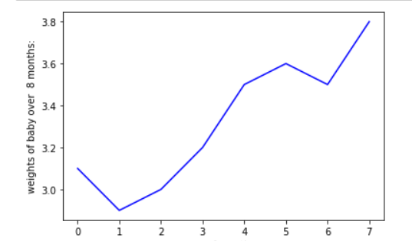

print("ploting with different points")

weights=[3.1,2.9,3.0,3.2,3.5,3.6,3.5,3.8]

plt.plot(weights,'r*') # b,r,bo,ro,g*,g^ color and point attributes

plt.ylabel("weights of baby over 8 months:")

plt.xlabel("no of months")

plt.show()

op:

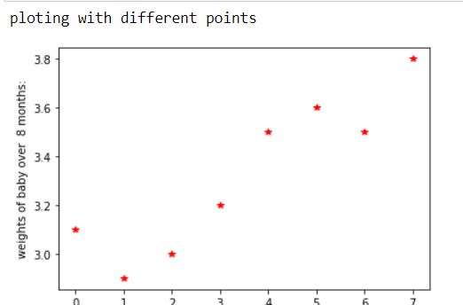

3.bar plot

print("bar")

country = ["ind","pak","usa","uk","bangla"]

revenue = [123.45,112,149.43,130.3,117.77]

plt.figure(figsize=(10,6)) #w=10,h=6

plt.bar(country,revenue)

plt.ylabel("revenue in millions")

plt.xlabel('country')

plt.suptitle(" country revenues")

plt.show()

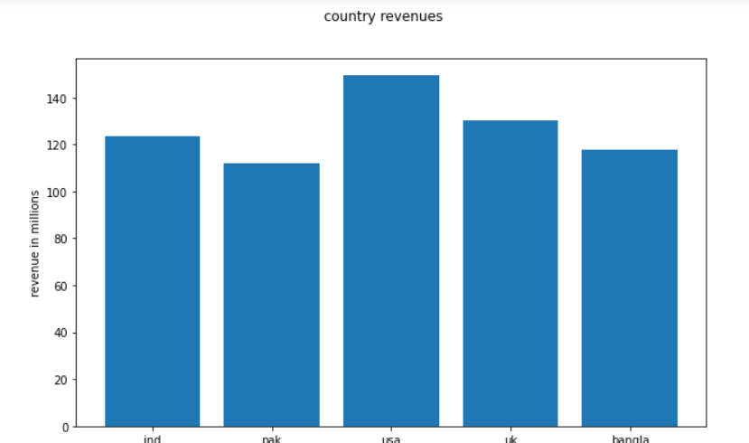

Horizontal bar:

plt.barh(country,revenue)

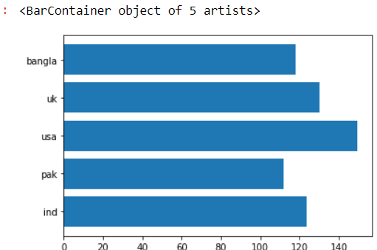

Pie chart:

response = ['research','job','degree','status','passion']

counts = [22,76,55,17,10]

print("ploting 2 plots on same figure ")

plt.figure(figsize = (9,9))

plt.subplot(211)

plt.bar(response,counts,color='gray')

# vrtcle ploting

plt.show()

plt.subplot(212)

plt.pie(counts,labels=response,autopct ='%1.2f%%')

plt.show

op:

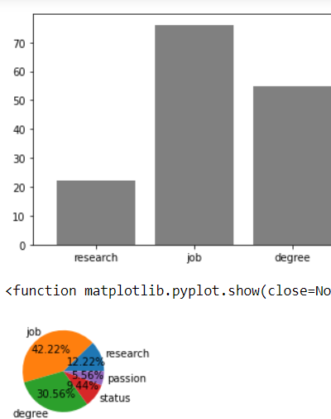

4.bubble polt with different attribure

print("bubble plot with dif colors")

#different colrs for dif points,dif size

x=np.random.rand(40)

y=np.random.rand(40)

colors=np.random.rand(40)

plt.scatter(x,y,s=2*100,c=colors)

op:

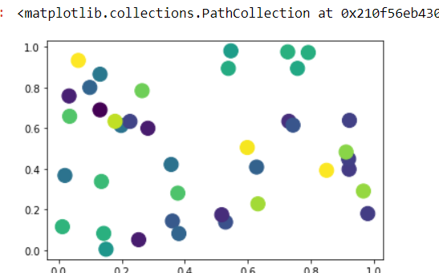

With different size ,random colors

#also we can use transparency in color: alpha=0.4/0.3/0.5

x=np.random.rand(30)

y=np.random.rand(30)

color=np.random.rand(30)

plt.scatter(x,y,c=color,s=2*500,marker='*',alpha=0.4) #alpha means transparency

op:

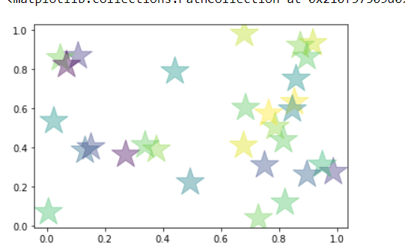

plt.scatter(x,y,c=color,s=2*600,marker='s',alpha=0.3)

#marker attribute changes the shape of points(dot,bubble,triangle,square)

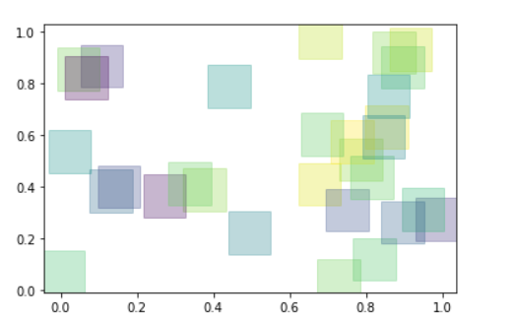

print("box plot") #used to show meand and outliers

data=[10,20,30,40,50,70]

plt.boxplot(data)

#with 1 parameter

plt.show()

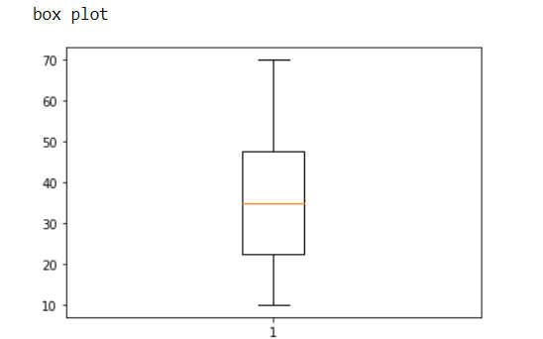

#box plot provides identification of outliers,distribution of variables,mean

#scater plot used to visualize the clusters and outliers

Ex7:

df = pd.DataFrame(np.random.rand(10,5),columns=['A','B','C','D','E'])

df.plot.box()

op:

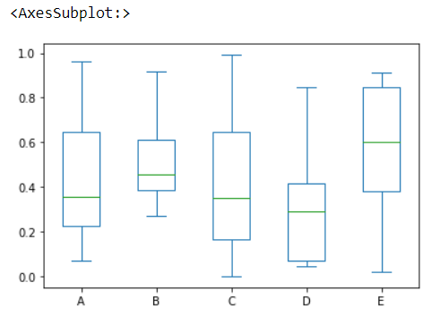

_________________________________________________________________________-date:15-09-2023

Generators:it retruns generator object

It gives iterator,

Generators are created using functions with yield keyword

Next() -> execution resumes where it is left over

If we want to one value at a time use generator

Generator s uses memory efficient

Ex:1

print("generator gives iterators:")

# genrator created with yeild keyword

def topten():

    n=1

    while n<=10:

        sq = n*n

        yield sq

        n =  n+1

values = topten()

for i in values:

    print(i)

ex2:

# fibanoci series using generator

def fib():

    a,b =0,1

    while True:

        yield a

        a,b =b,a+b

fib_generator = fib()

for i in range(10):

    print(next(fib_generator))

REGULAR EXPRESSIONS:

Used to find and search required pattern

For this we have to import re module

The re module offers a set of functions that allows us to search a string for a match:

|  |  |
| --- | --- |
| **Function** | **Description** |
| [findall](https://www.w3schools.com/python/python_regex.asp#findall) | Returns a list containing all matches |
| [search](https://www.w3schools.com/python/python_regex.asp#search) | Returns a [Match object](https://www.w3schools.com/python/python_regex.asp#matchobject) if there is a match anywhere in the string |
| [split](https://www.w3schools.com/python/python_regex.asp#split) | Returns a list where the string has been split at each match |
| [sub](https://www.w3schools.com/python/python_regex.asp#sub) | Replaces one or many matches with a string |

Ex:

import re

print("* means search for 0 or more occurence")

print(" .  means search for 1 or more occurence")

print("? means serch for 0 or 1 occurence")

print(" {} means exactly specified no of occurence")

text = "Accelyzei is an innovative , accelarate "

x=re.split("\s",text)

print(x)

y=re.split("\s",text,1) # split onl 2 occurence

print(y)

def check_password(password):

    if 8 <= len(password) <= 20:

        if re.match('^(?=.*\d)(?=.*[a-zA-Z](?=.*[@$%^&+!=].*$)',password):

            return True

    return False

password = input("enter your password")

if check_password(password):

    print(" you used valid password pattern")

else:

    print("not valid password pattern")

op:

['Accelyzei', 'is', 'an', 'innovative', ',', 'accelarate', '']

['Accelyzei', 'is an innovative , accelarate ']

Password:Prasanna#123

You used valid password patern

->{} means exactly specified no of occurrence

->* means search for 0 or more occurence

-> . means search for 1 or more occurence

->? means serch for 0 or 1 occurrence

-> $ indicates end with particular string

Lambda :

It is a single line function and anonimou(name less)function

function defined using the **lambda** keyword.

Syntax: lambda arguments:expression

**nu= [1,2,3,4,5]**

**sq =list(map(lambda x:x**2 ,nu)) #single line expression reduce no of line code**

**print(sq)**

**lambd function comes with different functions(map,filter,reduce etc..)**

**1.filter():**

**->**When you want to select specific elements from an iterable based on a condition we can use filter()

->It returns a new iterable containing only the elements that satisfy the given condition.

Syntax:filter(func,iterabl)

Ex: such as extracting even numbers, filtering out invalid data, or selecting items that meet certain criteria.

Ex1:

print("filter function")

nums = [2,3,6,8,4,6,2,9]

even = list(filter(lambda n:n%2==0 , nums)) #if fuction return true or flase use FILTER()

**2.map():**

**->**The **map** function is used to apply a specified function to each element of an iterable

and return an iterable containing the results.

->used to transform data by applying a function to each item in a list.

It maps to list,set,tuple.

3.reduce():

->The **reduce** function is used to repeatedly apply a specified function to the elements of an iterable (e.g., a list) and accumulate the results.

->It is often used for tasks like summing all elements in a list or finding the maximum/minimum value in a list.

Ex:

print("filter function")

nums = [2,3,6,8,4,6,2,9]

even = list(filter(lambda n:n%2==0 , nums)) #if fuction return true or flase use FILTER()

double = list(map(lambda n:n+2,even))   # map function perform operations and map to list or set

print("double of nums using map",double)

sum = reduce(lambda a,b : a+b ,double)   # from all the values gives single value from the all operations

print("sum using reduce function:",sum)

com = ['a','c','c','e','l','y','z','e','i']

name = str(reduce(lambda a,b:a+b,com))

print("company name using reduuce",name)

op:

company name using reduce: accelyzei #accumulate the list values

Serialization:

->Process of converting complex data such as objects or dictionaries into a format to store,transmit easily

->it is used to save the state of an object to file and transmit over network safely

->store data in bytes

Use cases:

1.inter process communication

2. to improve perfomence

3.save state of object

*We use pickle librarie or json ,marshal libraries

Ex:

print("serialization : conveting complex data structure ,such as objects or dictionaries \n into a format that can be easily stored ,transmitter")

import pickle

data = {'name':'Keerthi','company':'Accelyzei','job':'developer','age':20}

with open('data.pkl','wb') as file:

    pickle.dump(data,file)    #serialization

with open('data.pkl','rb') as file:

    loaded_data = pickle.load(file)    # deserialization

print(loaded_data)

op:{‘name’:’keerthi’,’company’:’accelyzei’}

3.Decorators:

decorators are a powerful and flexible way to modify or extend the behavior of functions or methods without changing their code

methods to add some additional functionality or behavior.

Decorators are essentially functions that wrap other functions

Python provides several built-in decorators, such as **@staticmethod**, **@classmethod**, and **@property**, which are commonly used in object-oriented programming

Ex:

import functools

def div(a,b):

    print(a/b)  # if a>b

def smart_div(func):

    def inner(a,b):

        if(a<b):

            a,b = b,a

        return func(a,b)

    return inner

div =smart_div(div)

div(2,4)

we can create user defined decorators

in the above div () indirectly called using smart_div() decorator

smart_div provides addition features to div() function in division

uses of decorators:

*logging

*Authentication

*Aspect oriented programming

*Add extra features to existing functions

*ApI end

*Validations (to validate i/p params)

4.partial functions:

Partial functions in Python are functions that are derived from existing functions by fixing one or more arguments to specific values,

You can create partial functions in Python using the **functools.partial** function from the **functools** module.

Ex:

# partial functions

def multiply(x,y):

    return x*y

double = functools.partial(multiply,2)  # create a special argument

result = double(5)  #equvalent to multiple(x*y)

print("partial fuctions:",result)

here double(5) # is equivalent to multiple()

5.closure:

Closure is a function object that remembers values in enclosing scopes even if they are not present in memory

->flexible

->modular code design

Uses:

*Funtion Factories

*Data hiding and encapsulation

*Callback functions (passing functions as arguments to other functions)

*event handling

Ex:

print("closure remembers values enclosing scopes evnn they not present in memory")

def outer_fun(x):

    def inner_fun(y):

        return x+y

    return inner_fun

closure = outer_fun(10) # = innerfunction

print("closure : outer retuns innerfunc->",closure)

result = closure(23)  #thi add 10(from outer function) to 23

print(result)

Op:

closure : outer retuns innerfunc-> <function outer_fun.<locals>.inner_fun at 0x000001C0C0B88F70>

33

6.code Intraspection:

It refers to the ability to examine & analyse code at runtime.

Code inspection for debugging to understand code behaviour

Various built in functions are used

*dir(obj) #list all the attributes(methods) of an object

*type(obj) #determine the type of object

*help() #information about an obj or function ,

* import inspect #inspect module more advance access,manipulate attributes,source code,other info

Inspect.getmember(),inspect.getsource()

*__doc__ # to understand the purpose of data types associated with functions & classes

*callable() #checks if an obj callable or not

Ex:

print("code inspection")

import inspect

k = "name"

num = 4.8

def employee(a,b):

    print("names",a,b)

obj = employee('keerthi','tanuja')

print(dir(k))

op: etitem__', '__getnewargs__', '__gt__', '__hash__', '__init__', '__init_subclass__', '__iter__', '__le__', '__len__', '__lt__', '__mod__', '__mul__', '__ne__', '__new__', '__reduce__', '__reduce_ex__', '__repr__', '__rmod__', '__rmul__', '__setattr__', '__sizeof__', '__str__', '__subclasshook__', 'capitalize', 'casefold', 'center', 'count', 'encode', 'endswith', 'expandtabs', 'find', 'format', 'format_map', 'index', 'isalnum', 'isalpha', 'isascii', 'isdecimal', 'isdigit', 'isidentifier', 'islower', 'isnumeric', 'isprintable', 'isspace', 'istitle', 'isupper', 'join', 'ljust', 'lower', 'lstrip', 'maketrans', 'partition', 'removeprefix', 'removesuffix', 'replace', 'rfind', 'rindex', 'rjust', 'rpartition', 'rsplit', 'rstrip', 'split', 'splitlines', 'startswith', 'strip', 'swapcase', 'title', 'translate', 'upper', 'zfill']

print("type() of num=4.8 ",type(num))

print("type() of obj",type(obj))

op: type() of num=4.8 <class 'float'>

type() of obj <class 'NoneType'>

a= inspect.getmodule(obj)

print("a",a)

op:none # no module defined in the employee function

Date:20-09-2023

FastAPI features

FastAPI work flow

Path Parameters

Query Parameters

Request Body

Query Parameters and String Validations

Path Parameters and Numeric Validation

What is API:

Application programming interface . It is a set of rules and protocols that allows different software applications to communicate with each other.

It provides Data exchange ,security ,abstraction ,documentation.

FAST API:

Fast API is a Web Frame work for building RESTFUL API in python.

->when we requires high perfomence and scalable API , FAST API is better

MY APP < ----------> OTHER APP

(api) works as interface

1.Features of FAST API:

1.open API: or API creation, including declarations of path operations, parameters, body requests, security, etc.

*Automatic data model documentation with [**JSON Schema**](https://json-schema.org/)

*also allows using automatic **client code generation** in many languages.

2.Fast Perfomence:

As API is built on top of Starlette and Pydantic, making it one of the fastest Python web frameworks available

It provides asynchronous programming features in Python for maximum performance.

3. **Automatic Validation:**

It automatically validates request and response data using Python type hints and Pydantic models, which helps catch errors early in development.

4. **Automatic Documentation:**

FastAPI generates interactive API documentation automatically using tools like Swagger and ReDoc.

**5.Built-in Authentication:**

It provides built-in support for OAuth2, JWT, and other authentication mechanisms to secure your APIs.

6.Dependency injection

FastAPI allows you to define and inject dependencies into your route handlers,

And making it easy to manage database connections, authentication, and other resources.

**7.WebSocket Support:**

You can create WebSocket endpoints alongside traditional RESTful APIs.

Web socket: web socket refers to the ability of a web server and web application to establish multi duplex communication over channels(user-server communication)

*browser support

8. **Background Tasks:**

**->**FastAPI supports background tasks and periodic tasks using Python's built-in asyncio features.

9. **Middleware Support:**

we can add middleware to customize the request/response pipeline.

Work Flow of FAST API:

->Controllers

->database

->model

->Schema

->Service

1. **Installation:** we start by installing FastAPI and any additional dependencies you might need

Command: Pip install fastapi uvicorn

2. **Creating a FastAPI App:**

We create a FastAPI application instance and define your API routes using Python functions.

We can also define models using Pydantic classes to validate input and output data.

3. **Defining Routes:**

we define API routes by creating Python functions with decorators like

**@app.get("/")**, **@app.post("/items/")**.

these decorators specify the HTTP method and URL path for each route.

4. **Request Handling:**

Inside your route functions, you define the logic to handle incoming requests, process data, and return responses.

**5.Running the App:**

You run your FastAPI application using a web server like Uvicorn:

Ex:uvicorn myapp:app –host—address

Here, **myapp** is the Python file containing our FastAPI application (**app** is the name of our FastAPI instance)

**6.Automatic Documentation:**

we can access the automatically generated API documentation at **http://localhost:8000/docs** or **http://localhost:8000/redoc** in your browser.

7.Testing:

We can test our application using testing tool like pytest

Pydantic:

Pydantic used in conjunction with Fast API for data validation,serialization(transmission of data)

*Automatically convert data between data types and JSON

*Type hinting :we can specify the expected tpes of fields

*custom validations

Ex:

From fastapi import FastAPI

From pydantic import BaseModel

app = Myapp()

class Item(BaseModel):

name:str

price:float

is_offer:bool = name

@app.post(“/item/”)

Async def create_item(item:item): -> no comparision b/w db

Asynchronization: tasks can be started and continue running

Efficient

Synchronization: task executed one after other in sequential manner

Some times slower the process